Jason Richard

SDEV 400-Secure Programming in the Cloud

Professor Puran Nebhnani

November, 18th 2018

Screen shot of being Logged into my non-root, admin AWS account

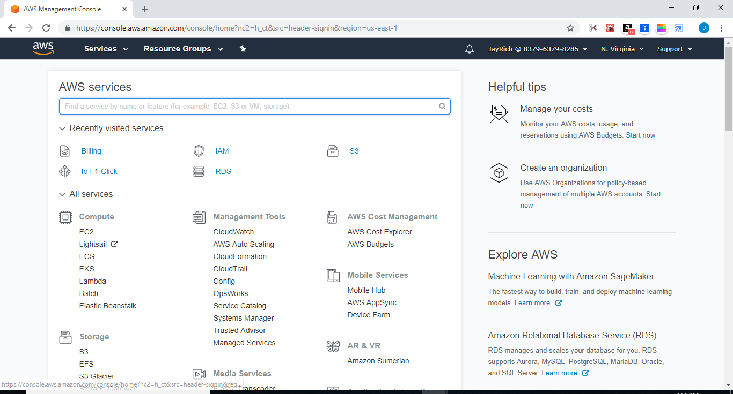

To create an S3 bucket, I clicked on the S3 Service located in the Storage category. 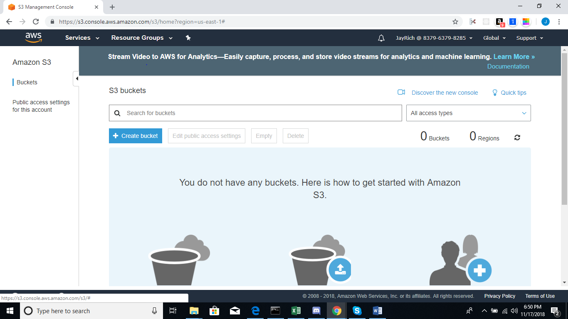

Creation of Bucket showing Bucket name and Region.

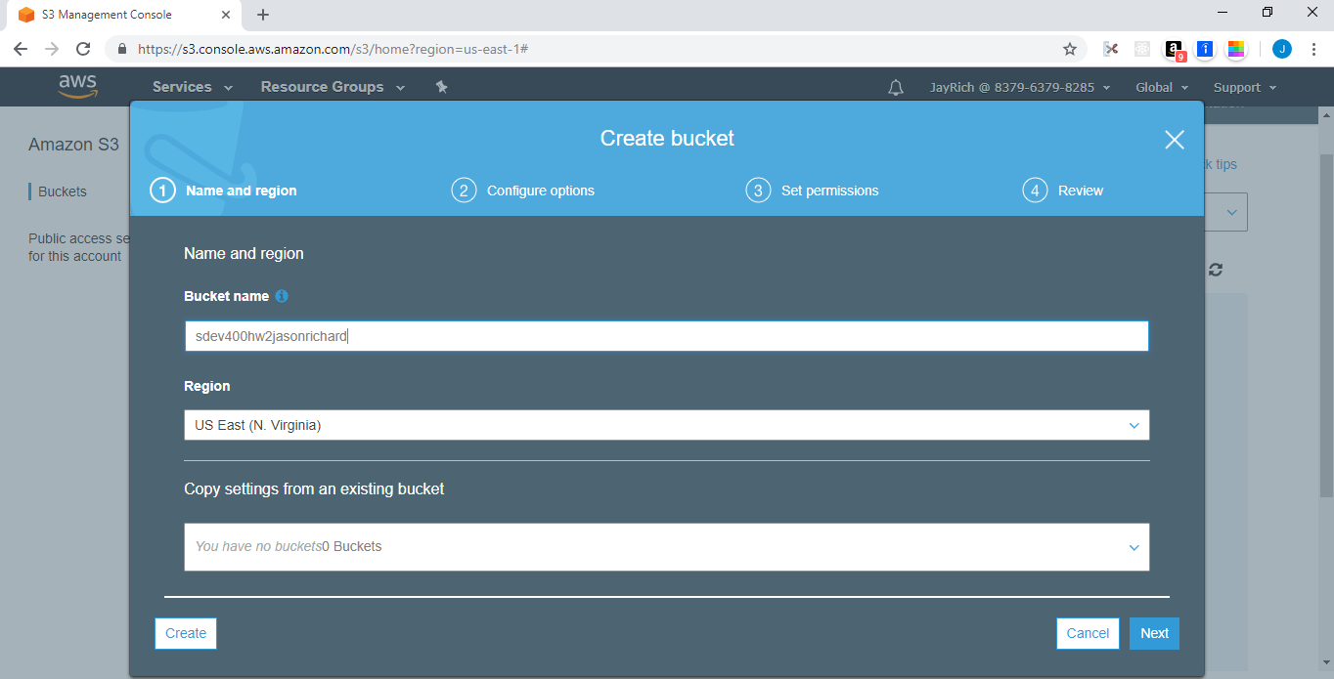

Successful Creation of Bucket of my S3 bucket

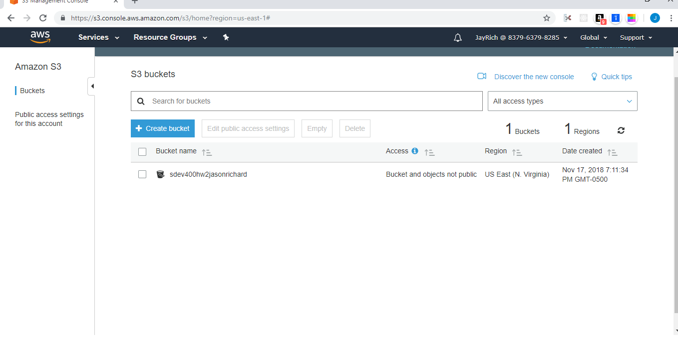

Creation of the folders, I clicked on the bucket to get to this screen to create the folders.

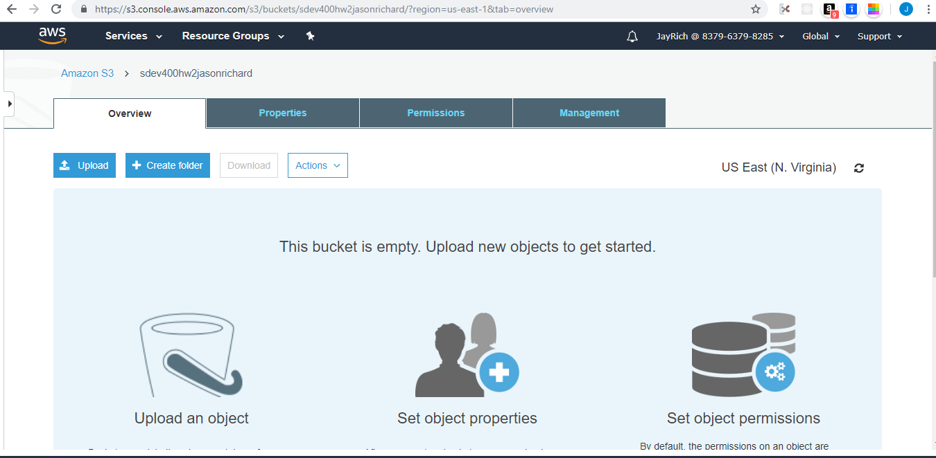

Students folder

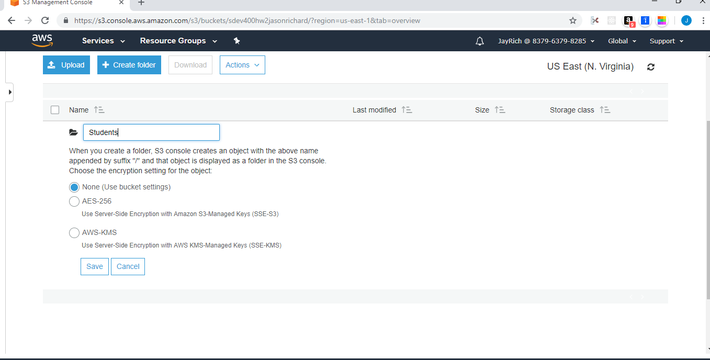

Faculty folder

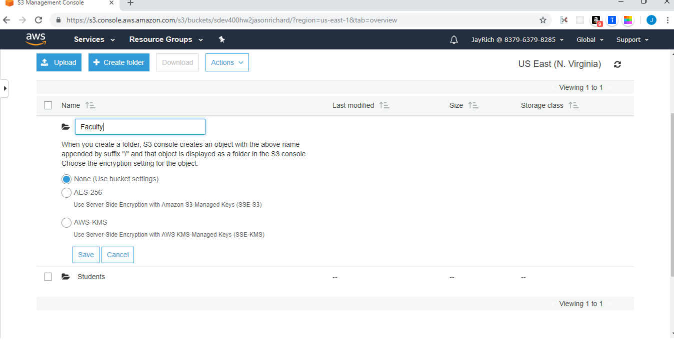

Admin folder

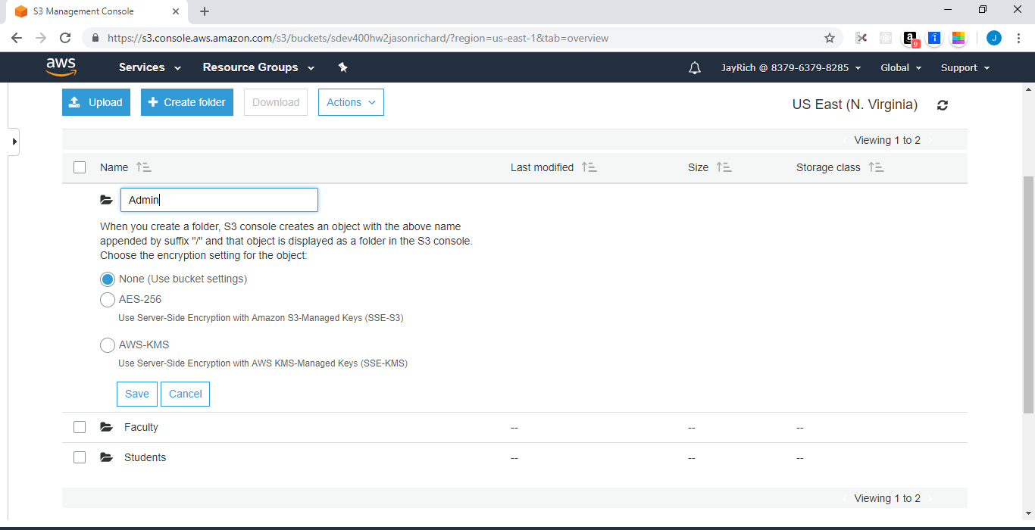

Successful creation of the 3 folders-Students, Faculty, and Admin

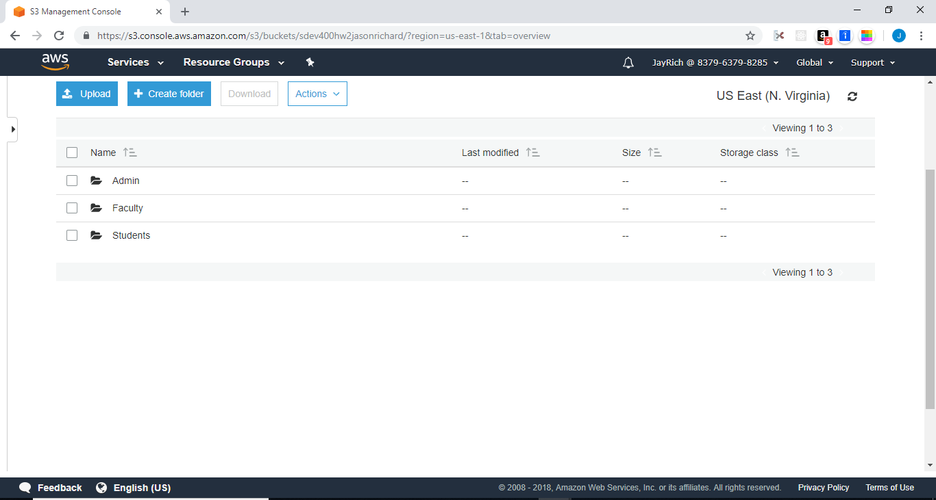

Creation of the 4 text files- Description, Organization, Rules, and Topics.

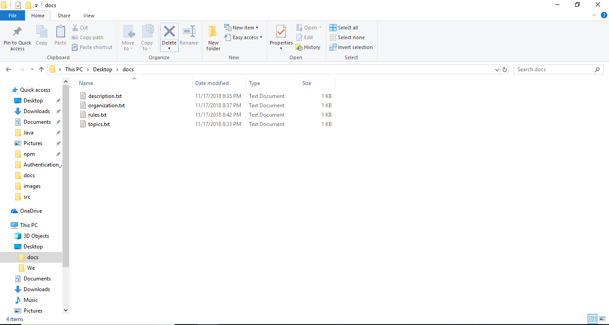

Creation of the batch file, AWSCLIS3.bat file containing the scripts to copy the files into the AWS folders of the sdev400hw2jasonrichard bucket

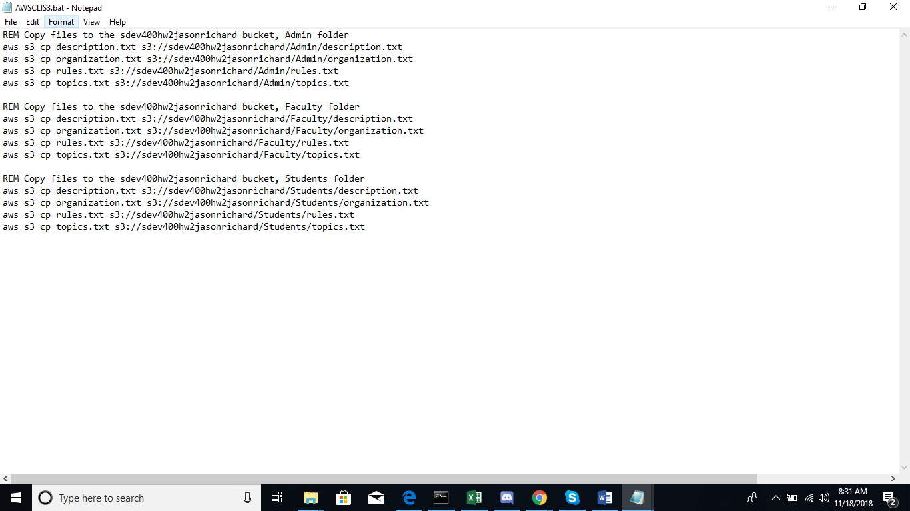

I couldn’t get the batch file to run successfully in the CLI so I had to copy each file individually.

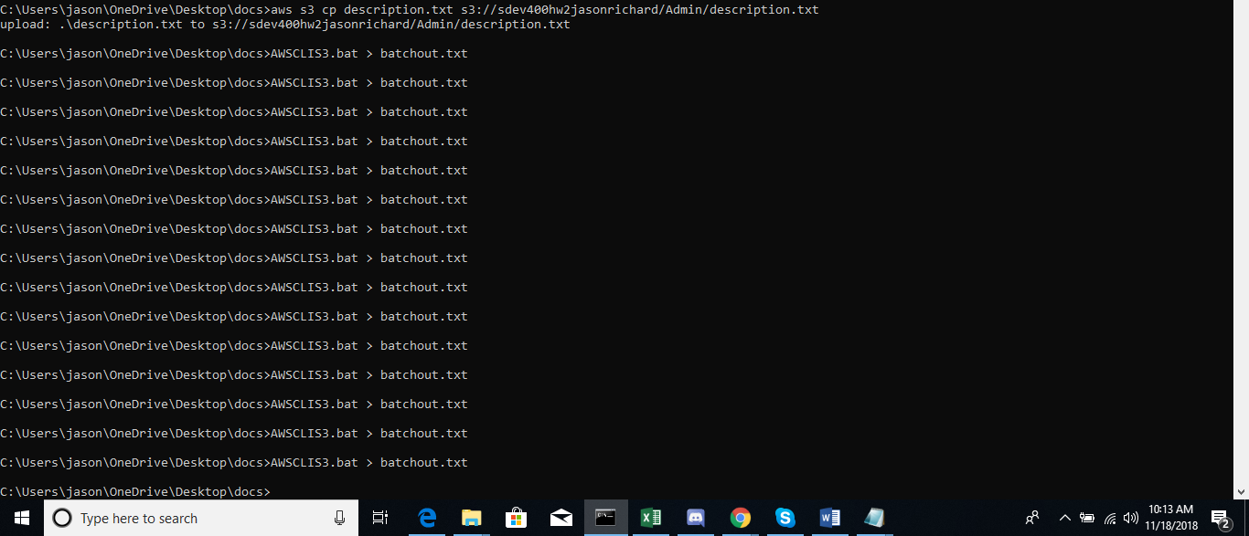

Command used to show that the files were copied successfully into the folders within the bucket

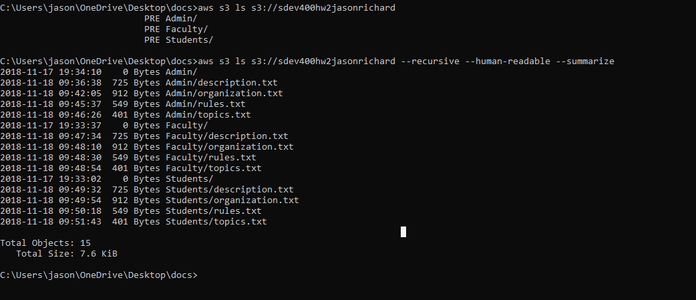

1. Creating the users

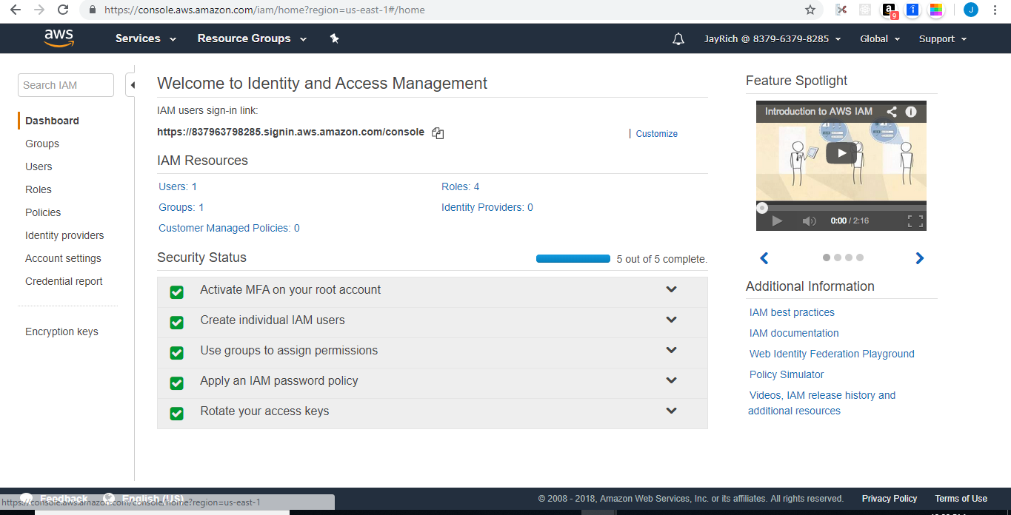

Users- Instructor, Secretary, Johnny, and JayRich- My Admin setup

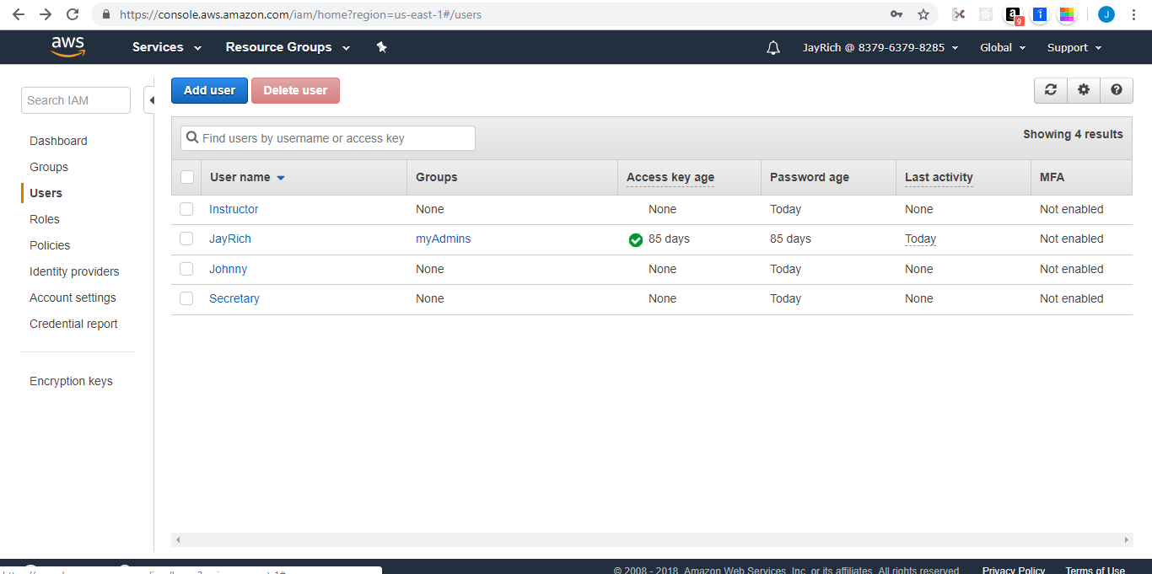

Creating Groups-Used the CLI to create groups named-students and staff

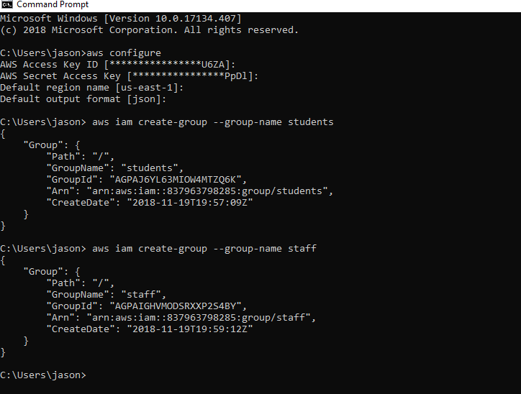

Adding Users to a Group using the CLI

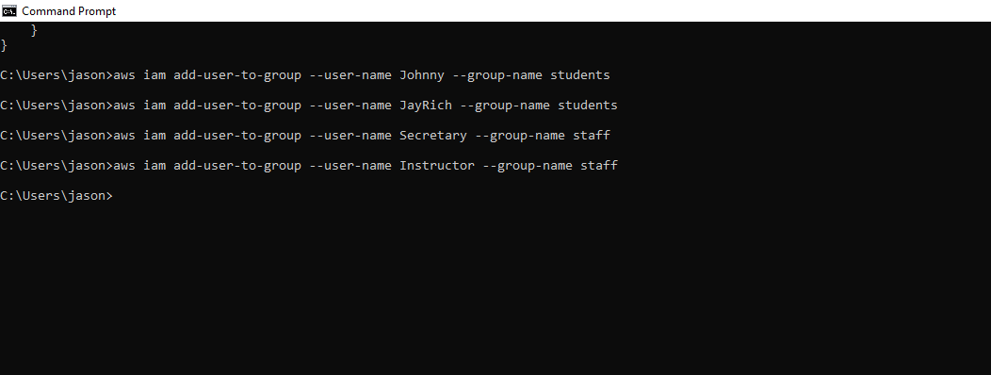

Success of adding users to groups as shown in AWS

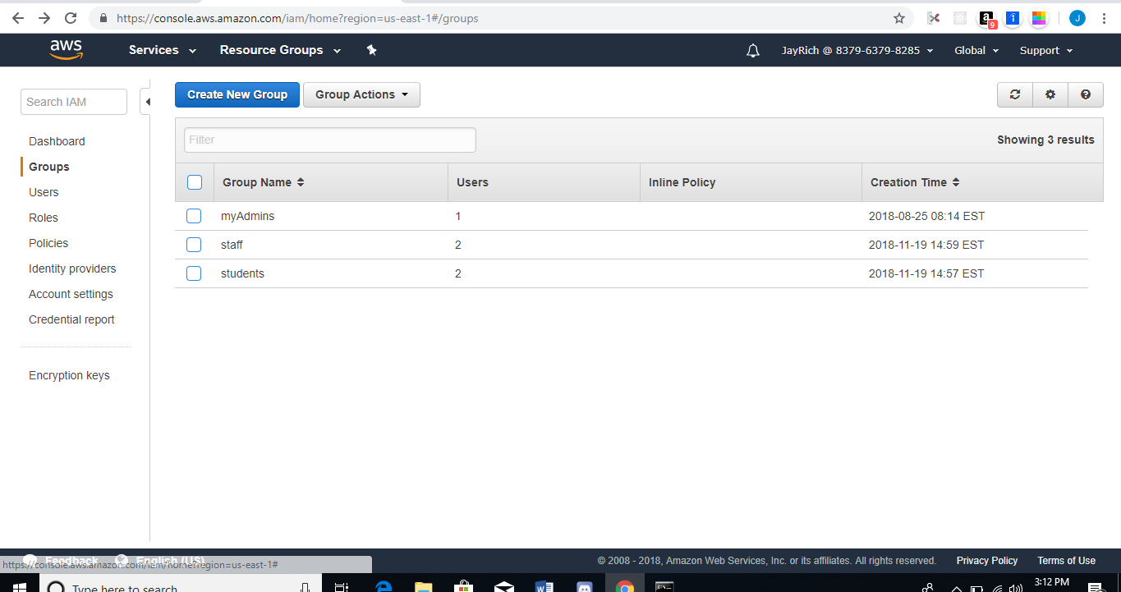

Creating Policies by clicking on the Create policy button

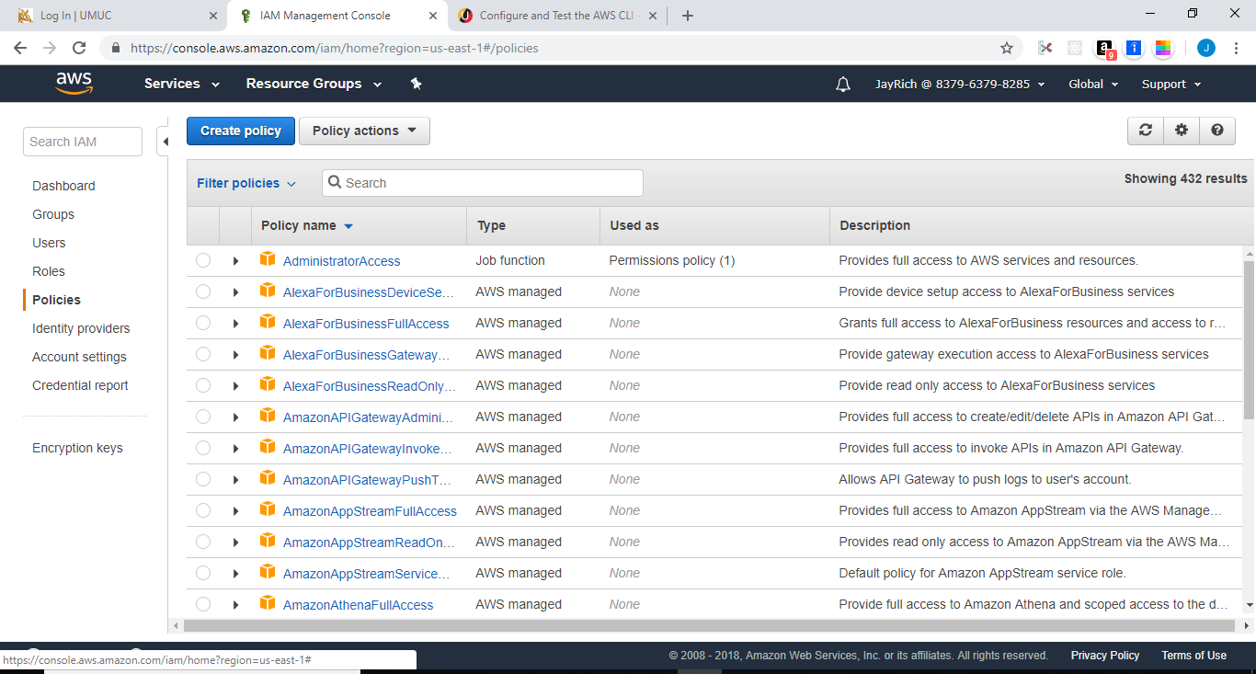

Service S3 selected, and Actions granted

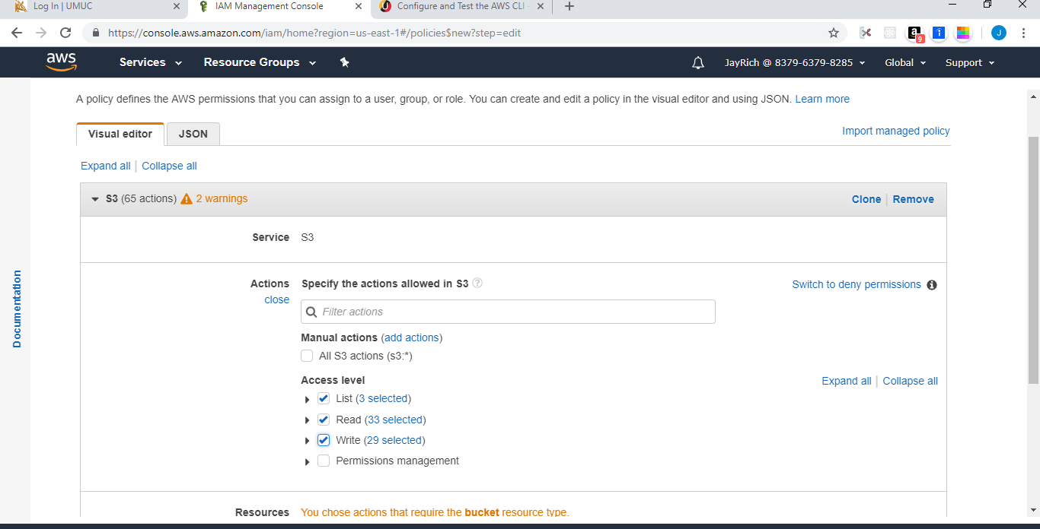

Bucket name sdev400hw2jasonrichard added to the ARN to give the access to the policies granted.

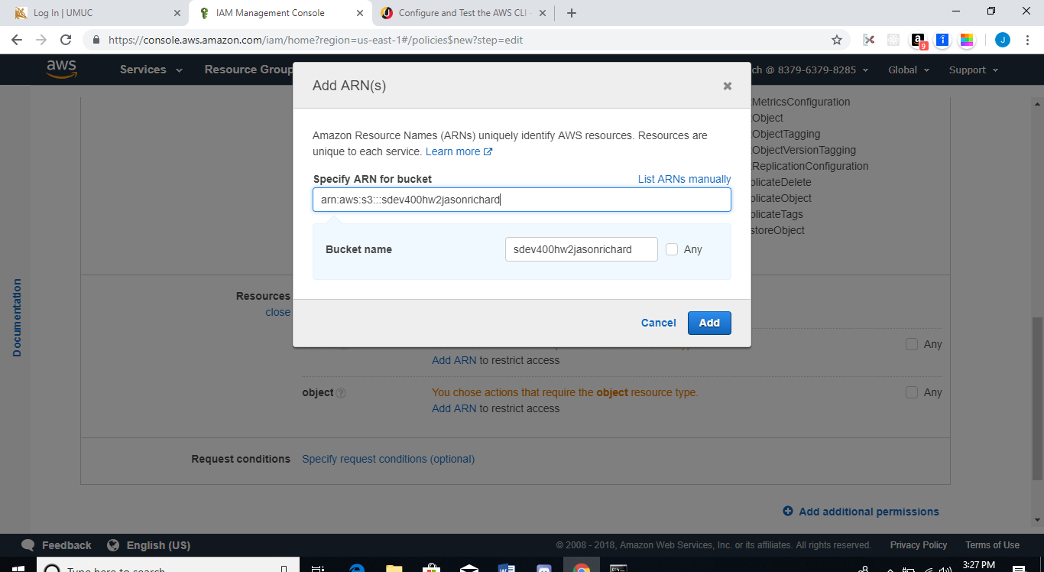

Object Source of Admin Added- This process was repeated for the folders of Faculty and Students

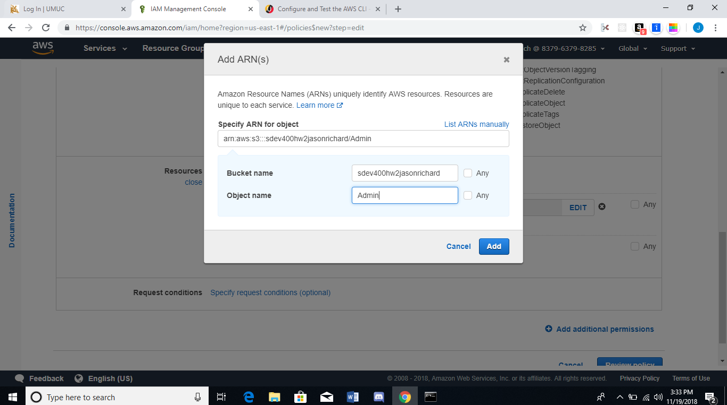

The policy name is Policys and the Description is Policys for Staff and Students

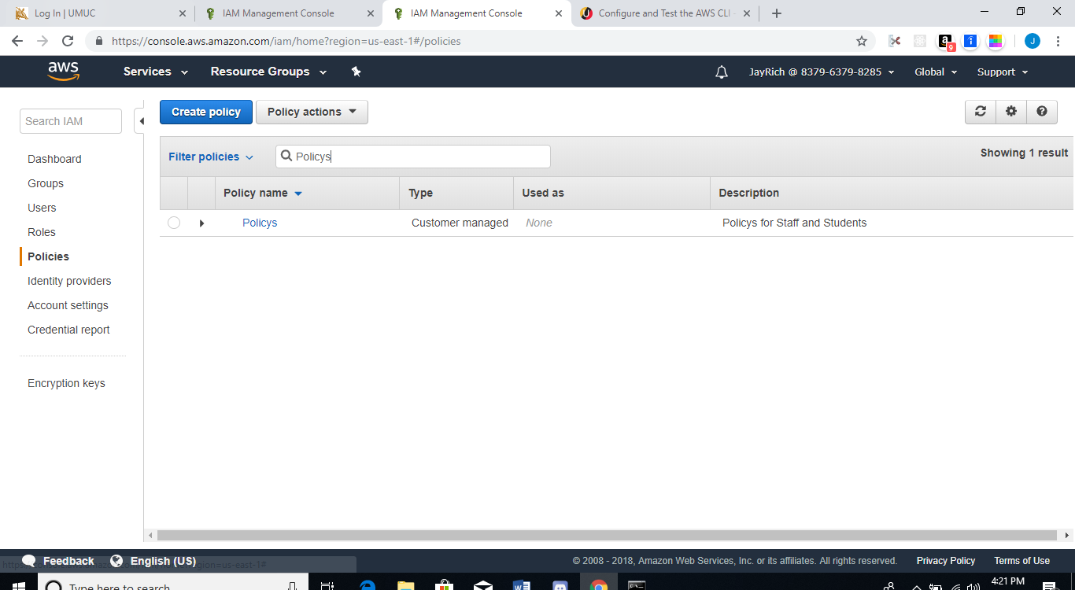

Policy added to the Groups

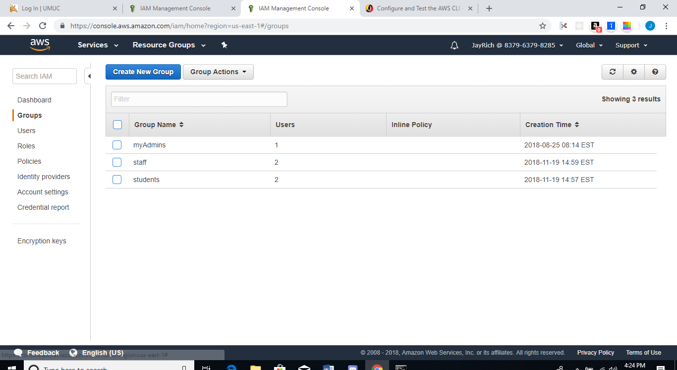

Attaching policy to the Group Staff

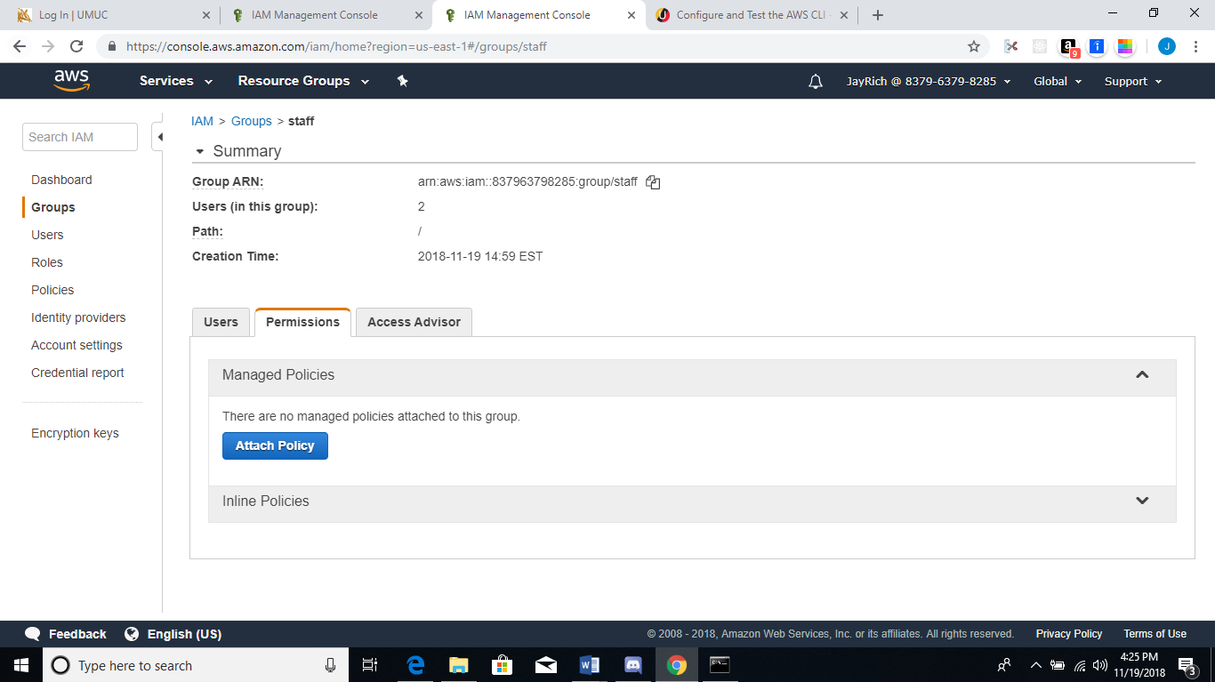

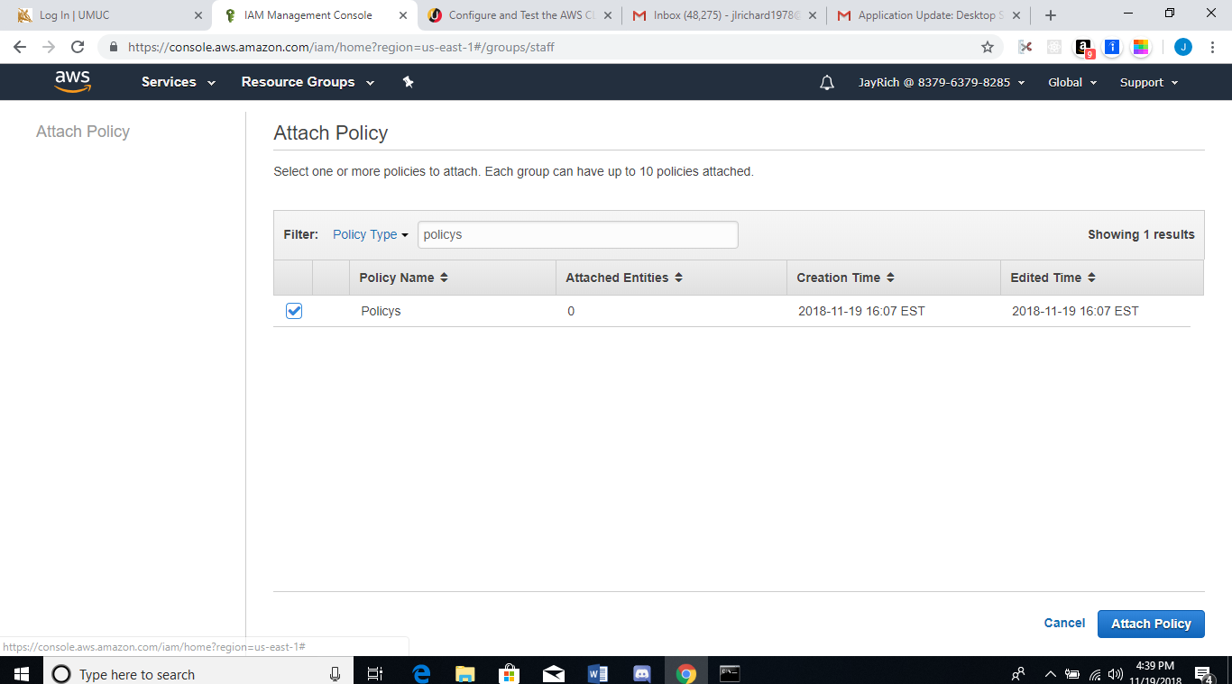

Users Security and Instructor of the Group Staff added to Policy

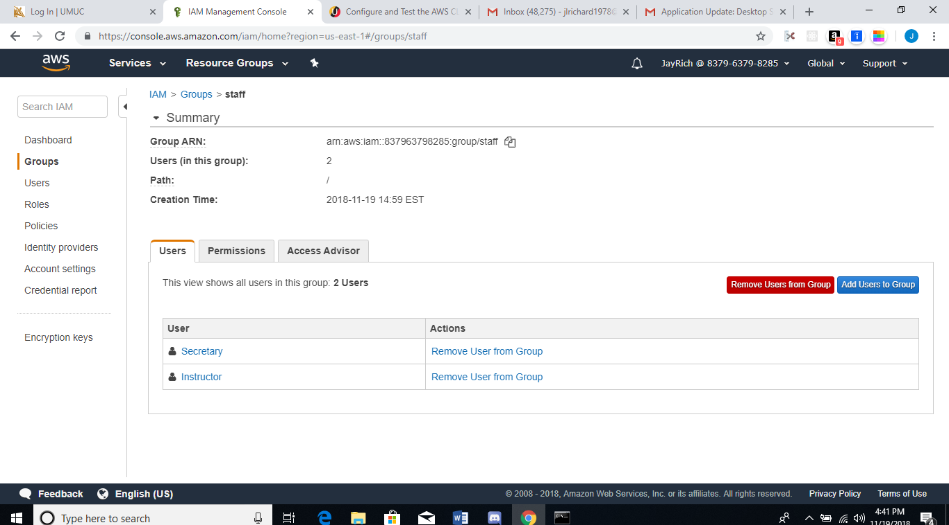

Attach Policy to Group students

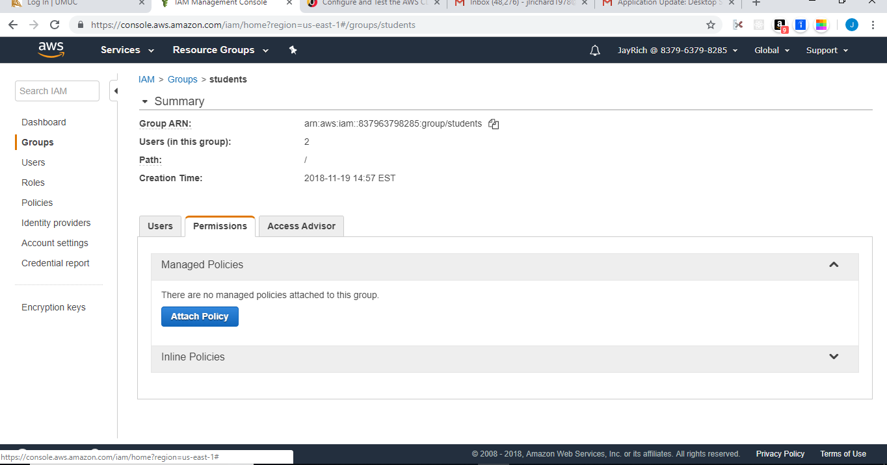

Users Johnny and JayRich of the Group Students added to Policy

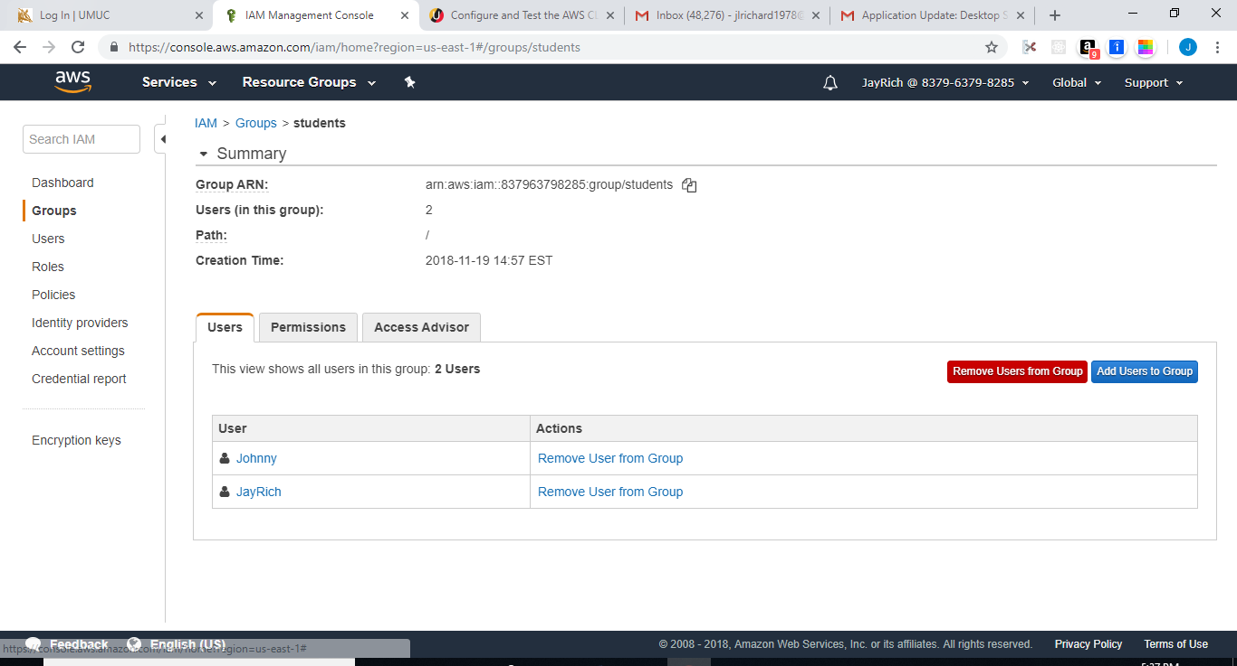

Launching the EC2 Instances

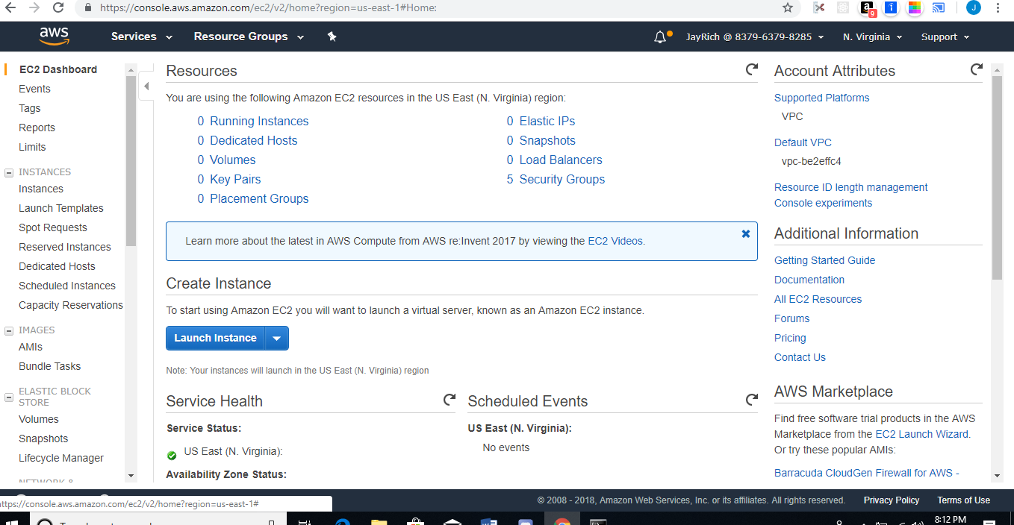

Selecting the AMI

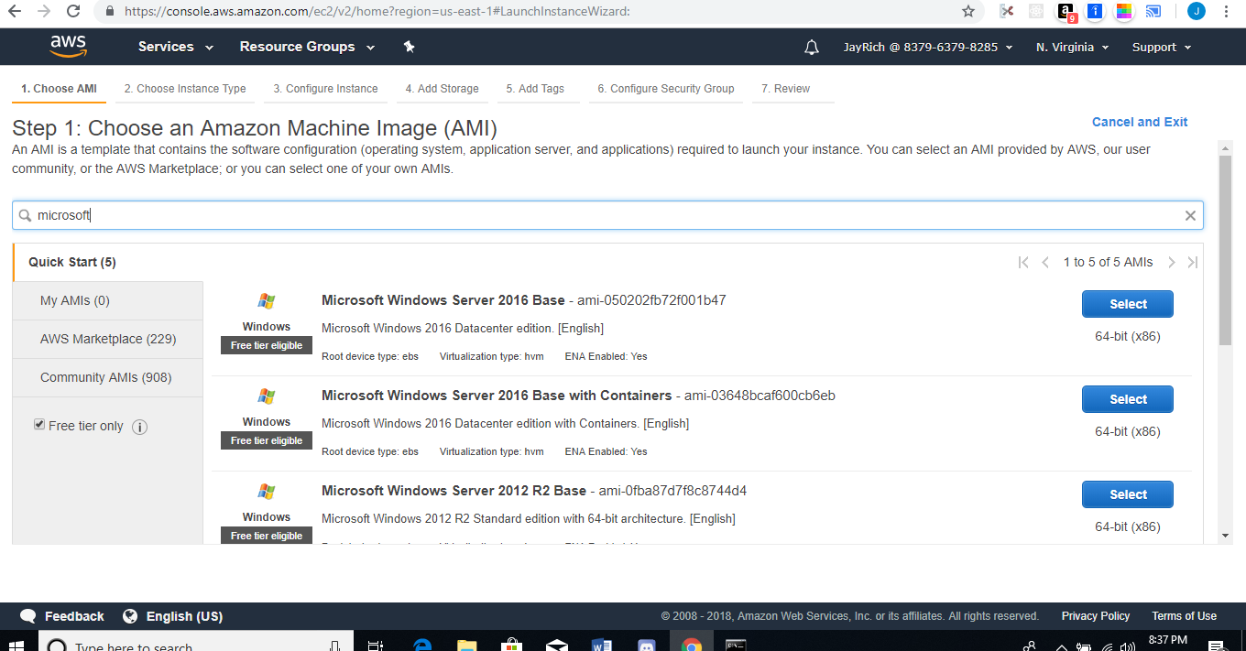

Selecting the Free tier Instance

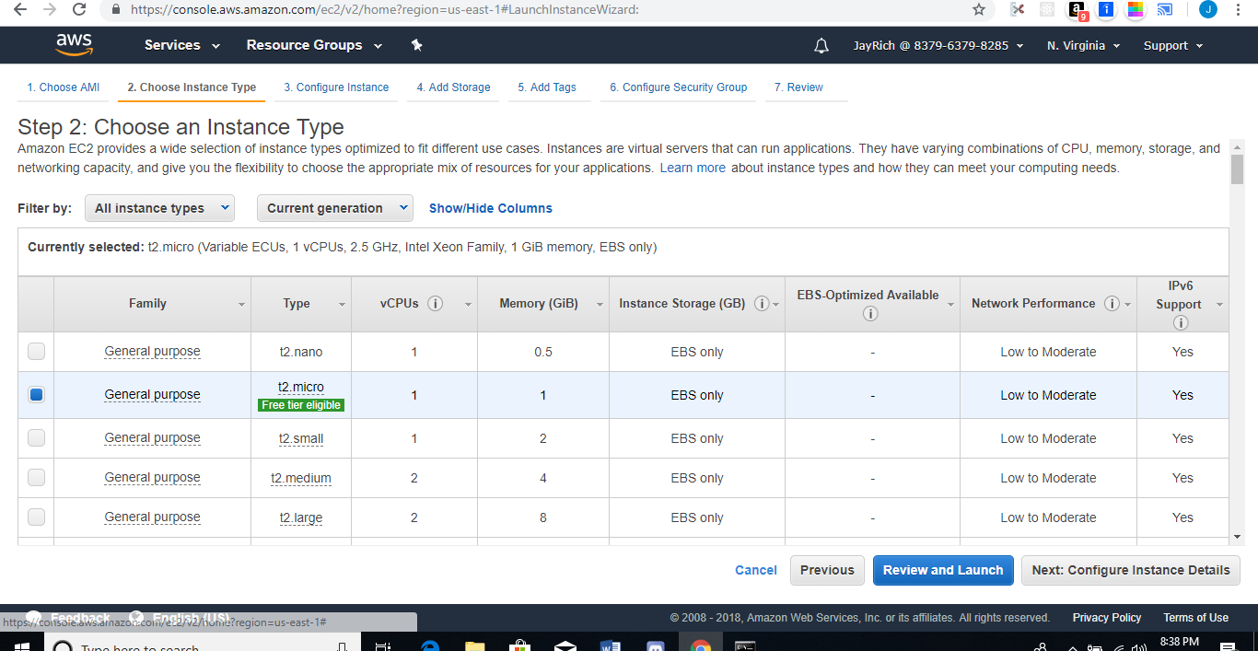

Editing the Security Group, Changing the Source to My IP

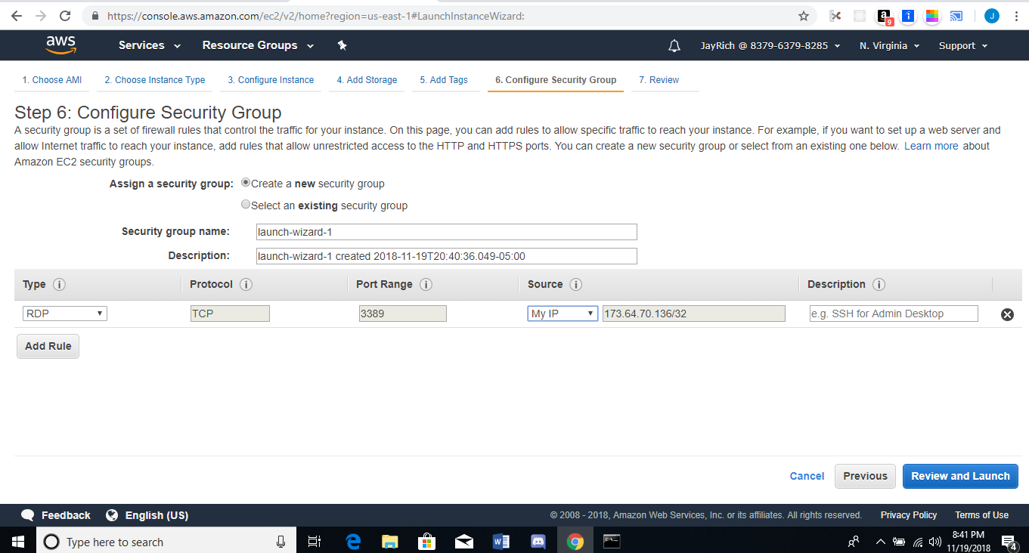

Review and Launching Instance

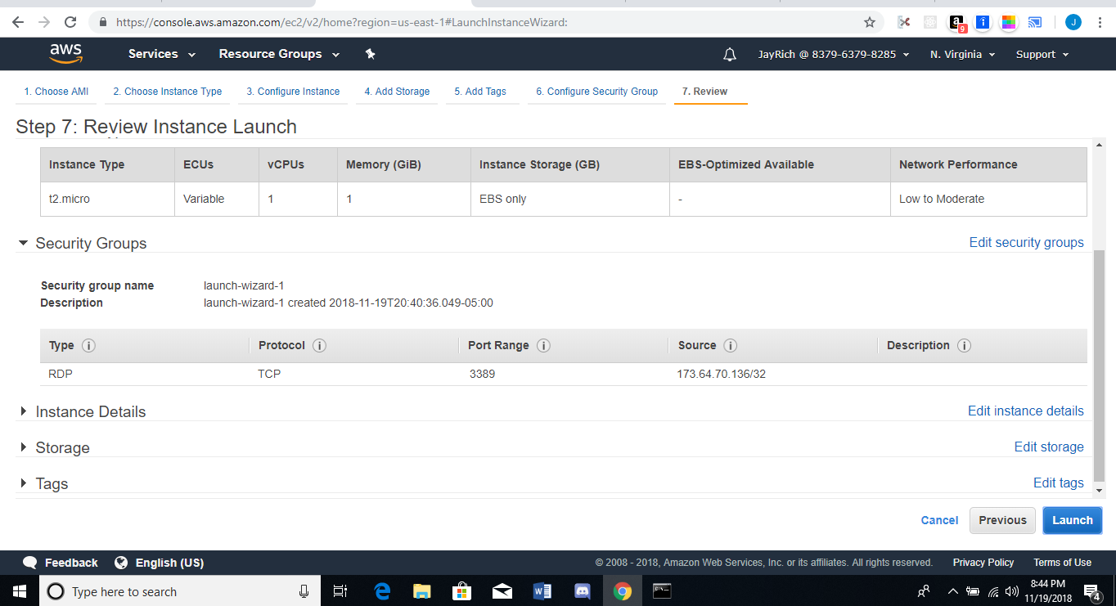

Creating a New Key Pair, and Downloading it to save

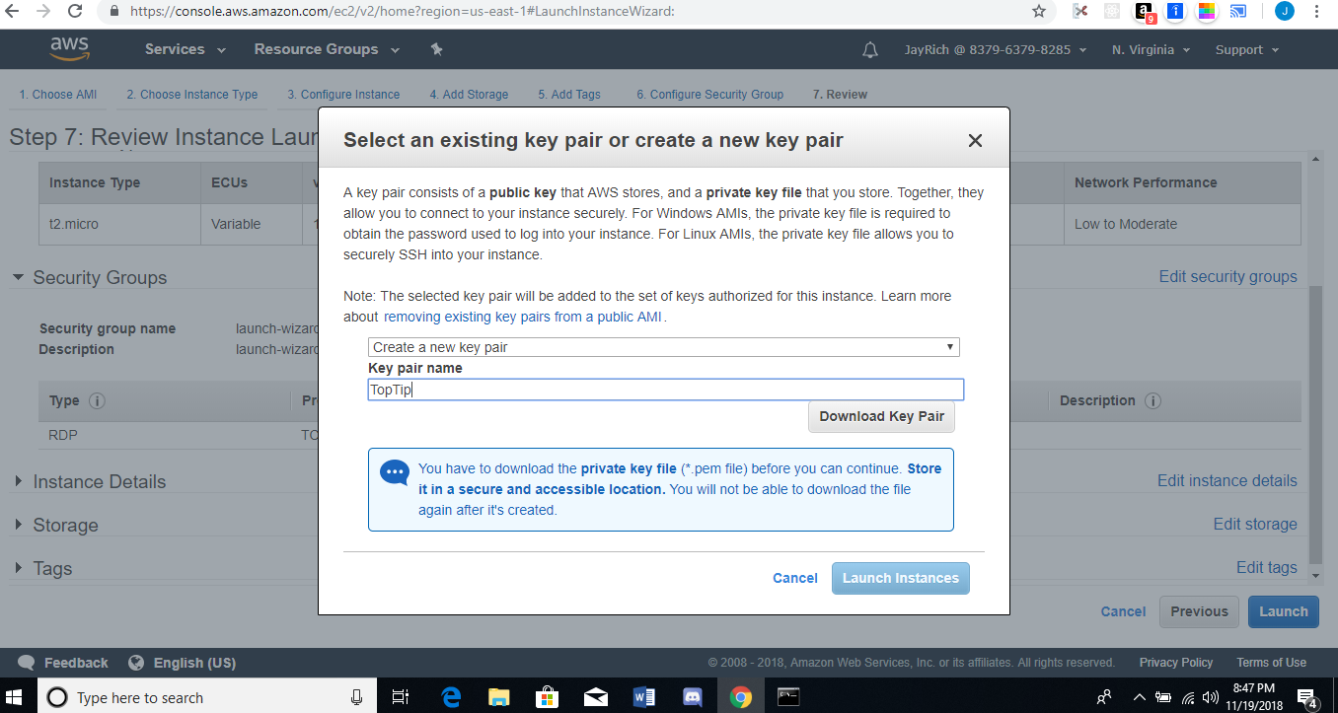

Microsoft Instance Successfully Created

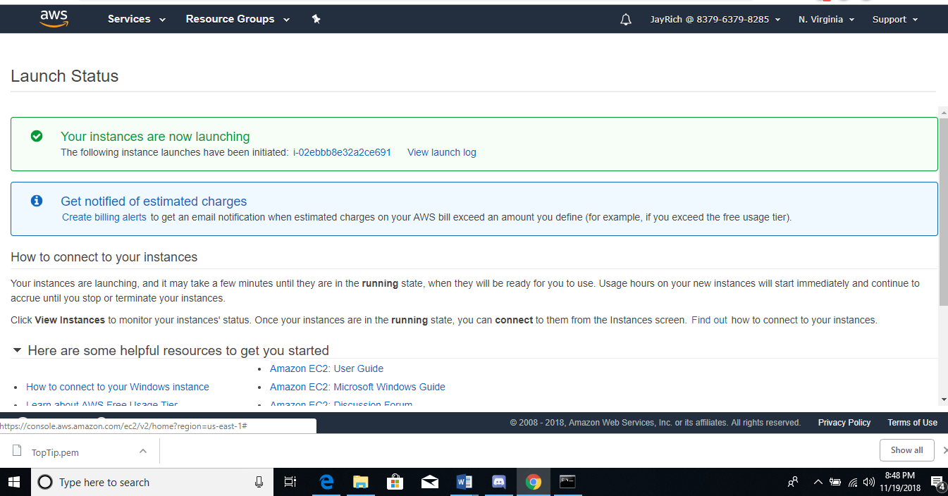

Getting Password for the Windows Instance

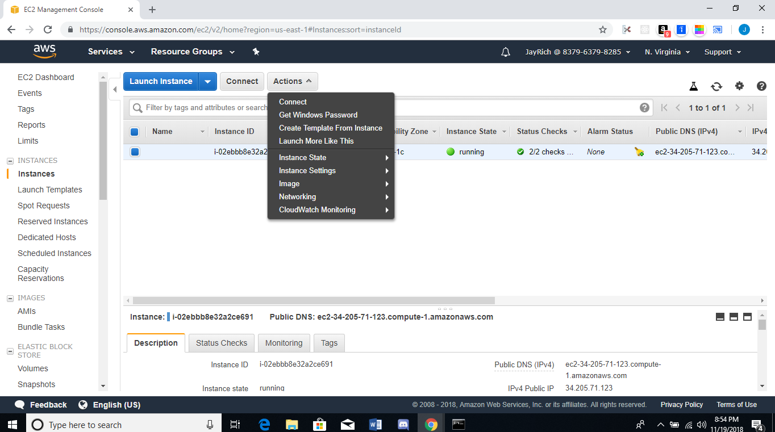

Getting the Windows Instance Password

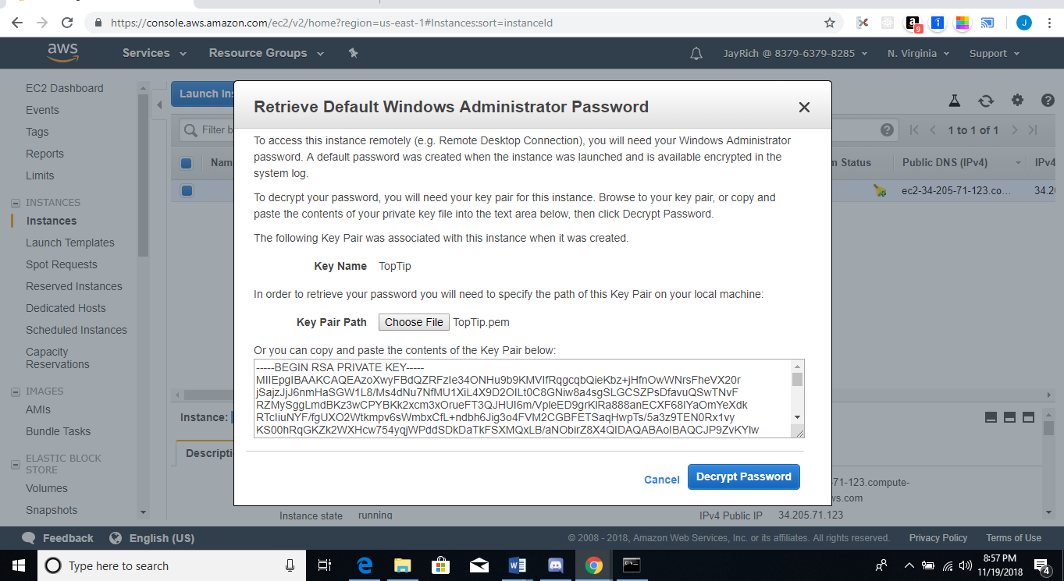

Decrypting the information to have the Password Displayed to log into the Windows IAM

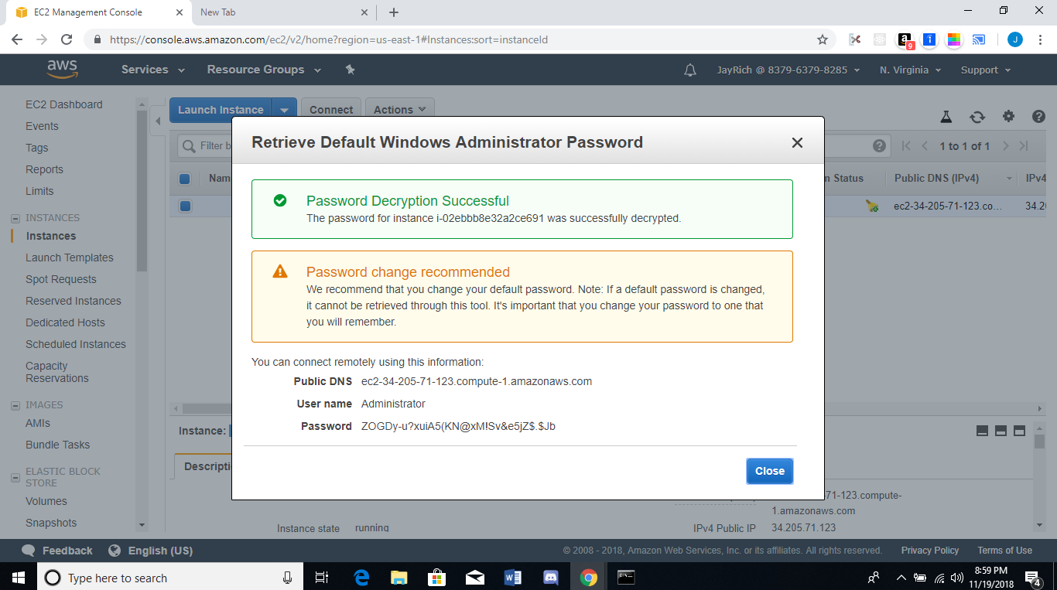

Connecting and Launching Instance

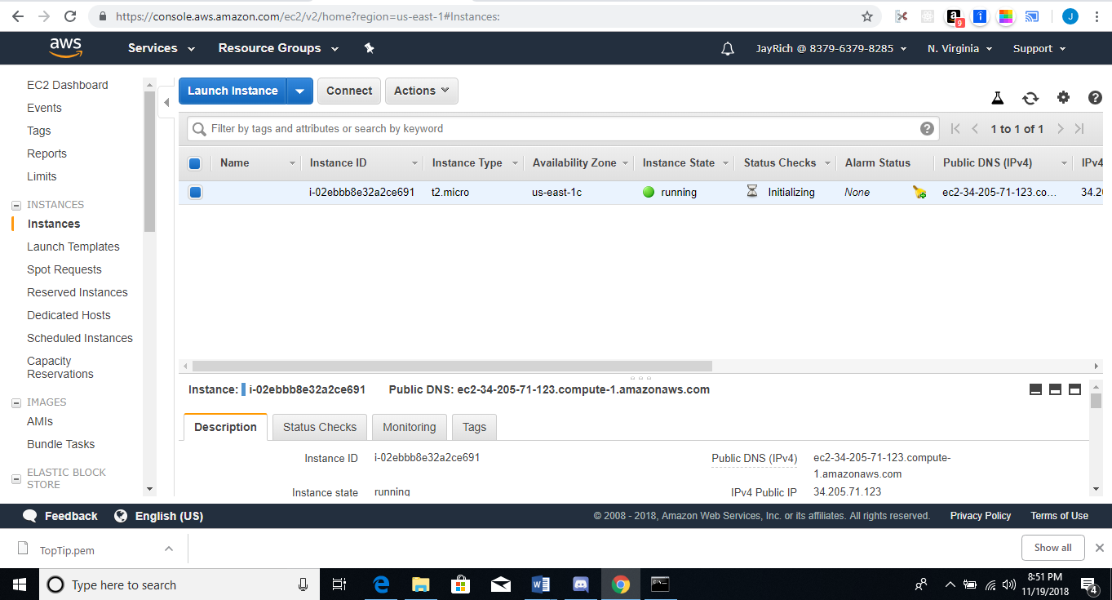

Connecting to the Instance by downloading the Remote Desktop File

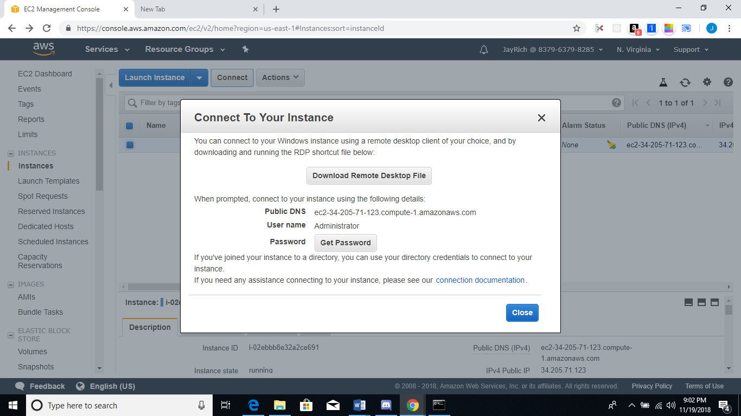

Downloading the Remote Desktop File

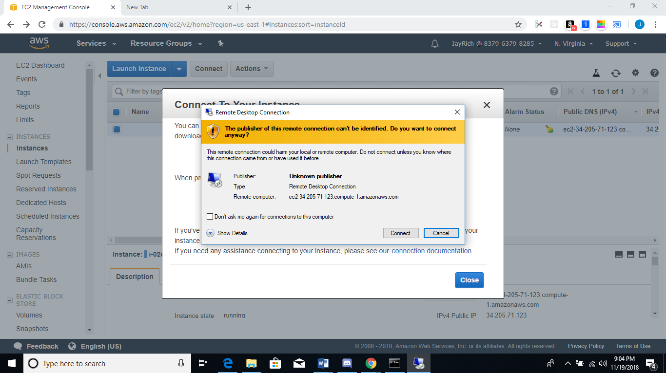

Entering Password to Connect to the Windows AMI

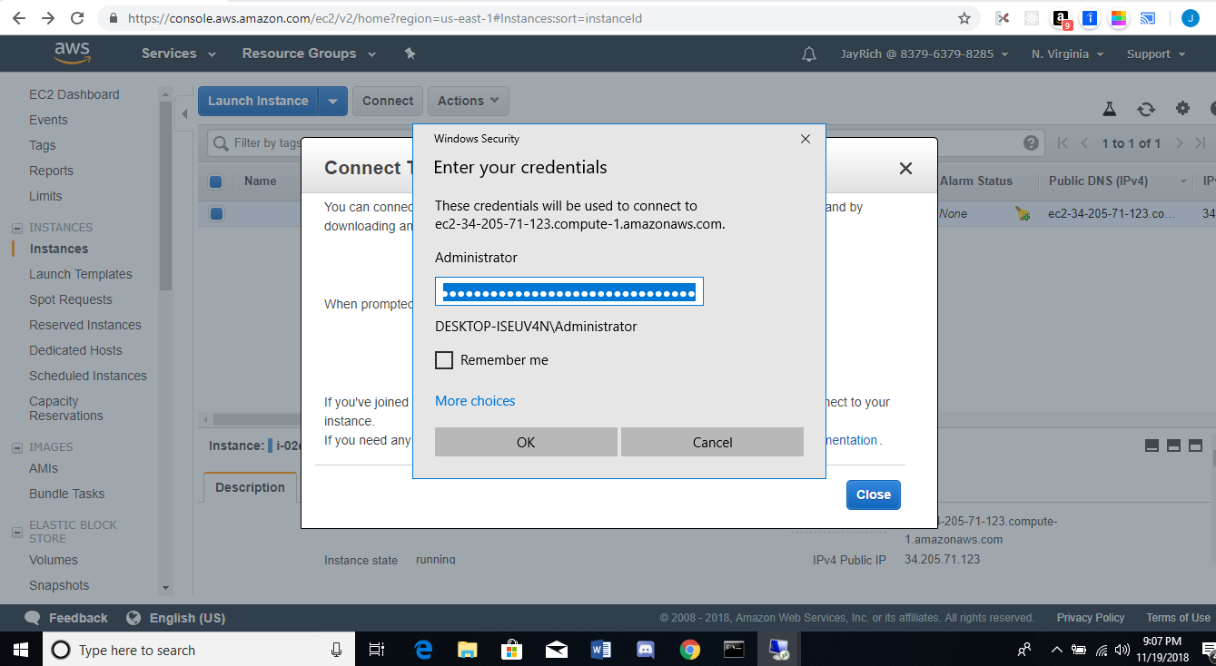



Successful login to the Windows AMI

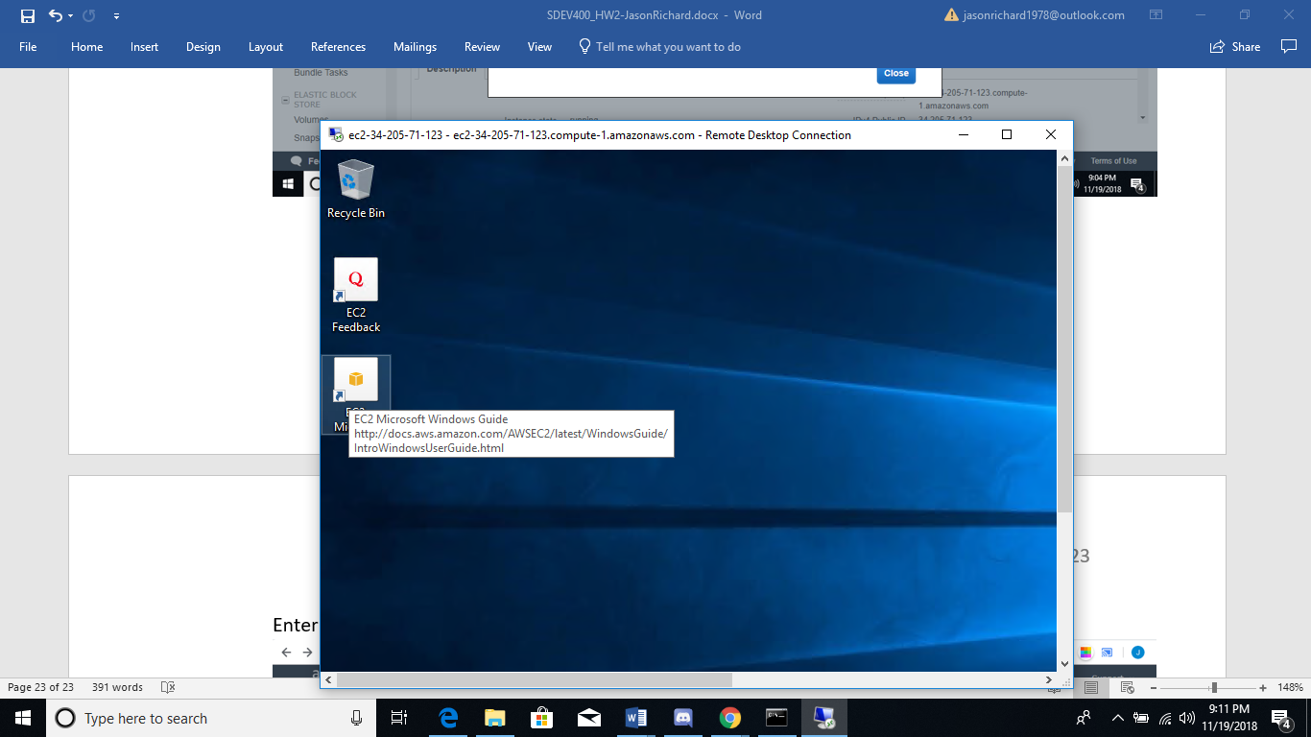

Changing the Admin Password

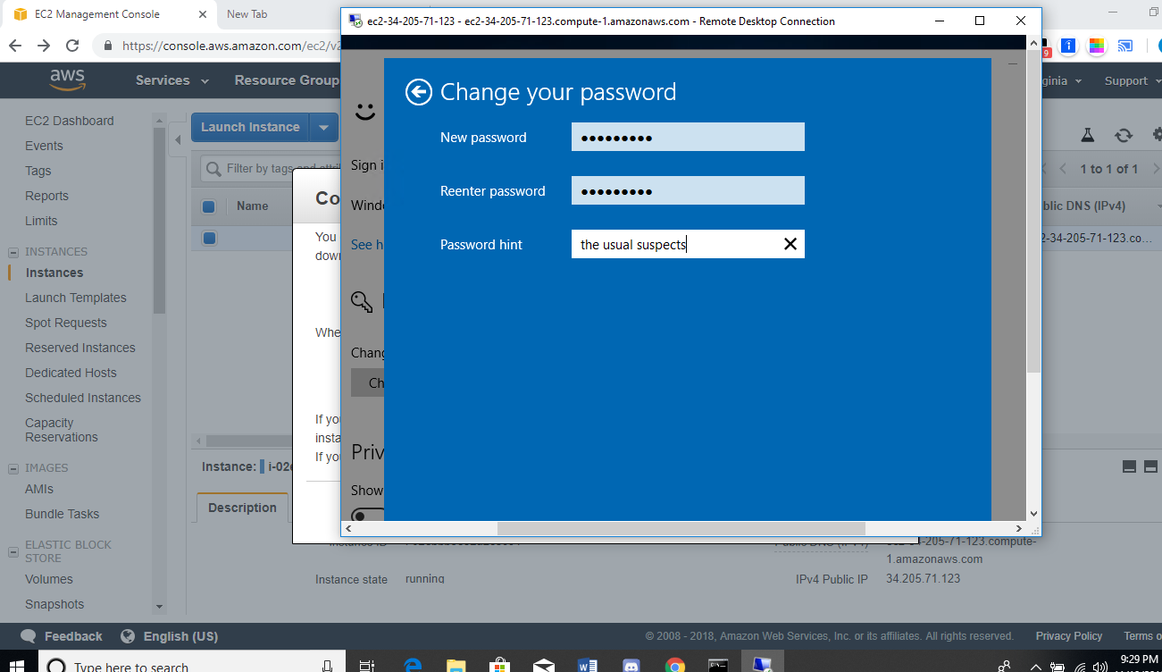

Terminating Instance

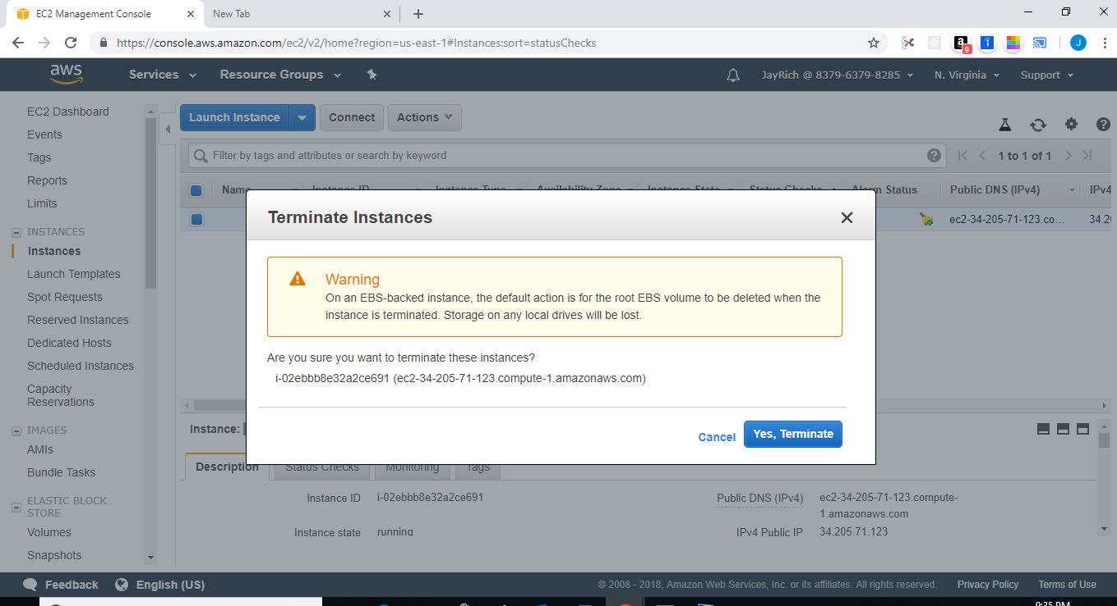

Terminating Instance

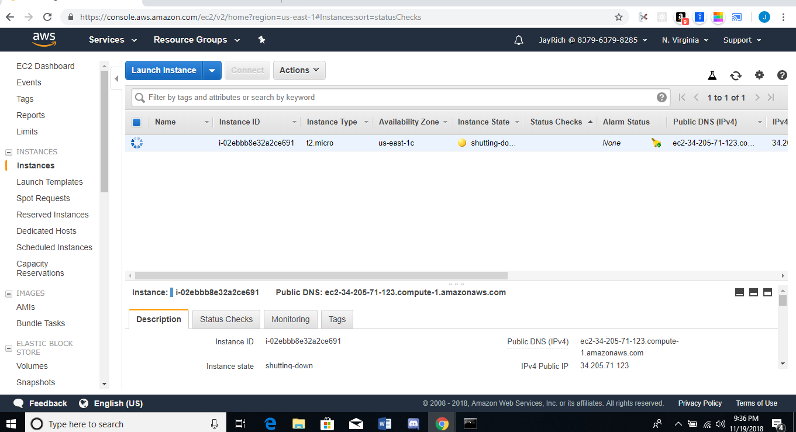

Instance Terminated

